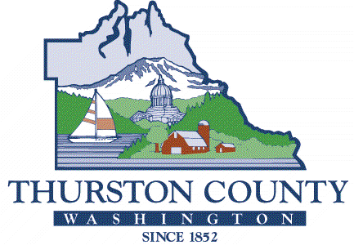
COUNTY COMMISSIONERS
Carolina Mejia, District One
Gary Edwards, District Two
Tye Menser, District Three Wayne Fournier, District Four Emily Clouse, District Five

BOARD OF EQUALIZATION

THURSTON COUNTY BOARD OF EQUALIZATION

Petition Withdraw Request

I, |  | , withdraw my taxpayer Petition Number 21-
to the Thurston County Board of Equalization for Parcel Number
for the 2021 assessment year for tax year 2022.

Signature Date

Please return the completed form to:

Thurston County Board of Equalization
3000 Pacific Avenue SE
Olympia, WA 98501

If you have any questions, please contact Ruth Elder, Clerk of the Board, at (360) 786-5135 or send
e-mail to ruth.elder@co.thurston.wa.us.

