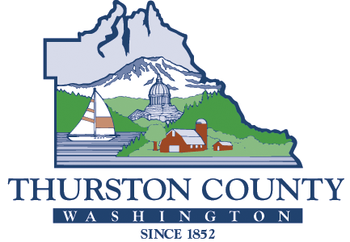

COUNTY COMMISSIONERS

Carolina Mejia Wayne Fournier

District One District Four

Gary Edwards Emily Clouse

District Two District Five

Tye Menser

District Three

**PUBLIC HEALTH AND**

**SOCIAL SERVICES DEPARTMENT**

David M. Bayne, MPH

Director

Dimyana Abdelmalek, MD, MPH

Health Officer

| Shellfish Protection Districts  Meeting Agenda |
| --- |

|  |  |
| --- | --- |
| Date: | September 24th, 2024 |
| Time: | 3:00-4:00 pm |

WA Department of Health Shellfish Growing Area Updates

1. Henderson
2. Nisqually
3. Others

Partner Updates (TCEH, Ecology, Stormwater, TCD, WSDA)

1. Henderson
2. Nisqually
3. Other Areas

Community Stakeholders

1. Updates or Questions

Specific Cases

1. Open table to ask about specific questions about sites of concern

Schedule next meeting

* Tuesday, December 10th, 3-4pm

Meeting Notes will be taken and posted online after each meeting.