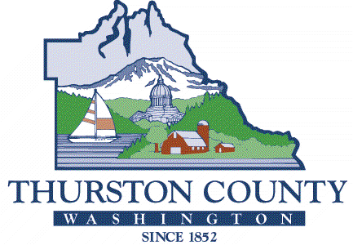
COUNTY COMMISSIONERS
Carolina Mejia, District One
Gary Edwards, District Two
Tye Menser, District Three Wayne Fournier, District Four Emily Clouse, District Five

BOARD OF EQUALIZATION

Taxpayer’s Declaration for Request for Reconvening

This is the declaration of Mr./Ms./Mrs.

Name

I am over the age of 18.

I reside at

Address

and own Parcel Number(s)

I did not receive the notice of valuation for the 2023 assessment year at least 15 days prior to the deadline for filing the petition and can show proof that the value was actually changed (see attached).

I declare under penalty of perjury under the laws of the State of Washington that the foregoing is true and correct.

Signature Date

This declaration form is provided for your convenience. Please file this if it is true; if it is not true, you should not file it. The Board cannot approve your Request for Reconvening under reconvening code 01 without your Declaration.

